import 'package:flutter/material.dart';

void main() {
runApp(const MyApp());
}

class MyApp extends StatelessWidget {
const MyApp({super.key});

@override
Widget build(BuildContext context) {
return const MaterialApp(
home: YellowScreen(),
// Keep debug banner (as you want it to show like default)
debugShowCheckedModeBanner: true,
);
}
}

class YellowScreen extends StatelessWidget {
const YellowScreen({super.key});
@override
Widget build(BuildContext context) {
return Scaffold(
backgroundColor: Colors.yellow, // Background color
appBar: AppBar(
backgroundColor: Colors.red, // Red top navbar
title: const Text(
'Uzma',
style: TextStyle(
color: Colors.white,
fontSize: 20,
fontWeight: FontWeight.bold,
),
),
elevation: 4,
),
body: const Center(
child: Text(
'Hello, World!',
style: TextStyle(
fontSize: 36,
fontWeight: FontWeight.w600,
fontStyle: FontStyle.italic,
color: Colors.black,
fontFamily: 'Roboto', // Default font
),
),
),
);
}
}

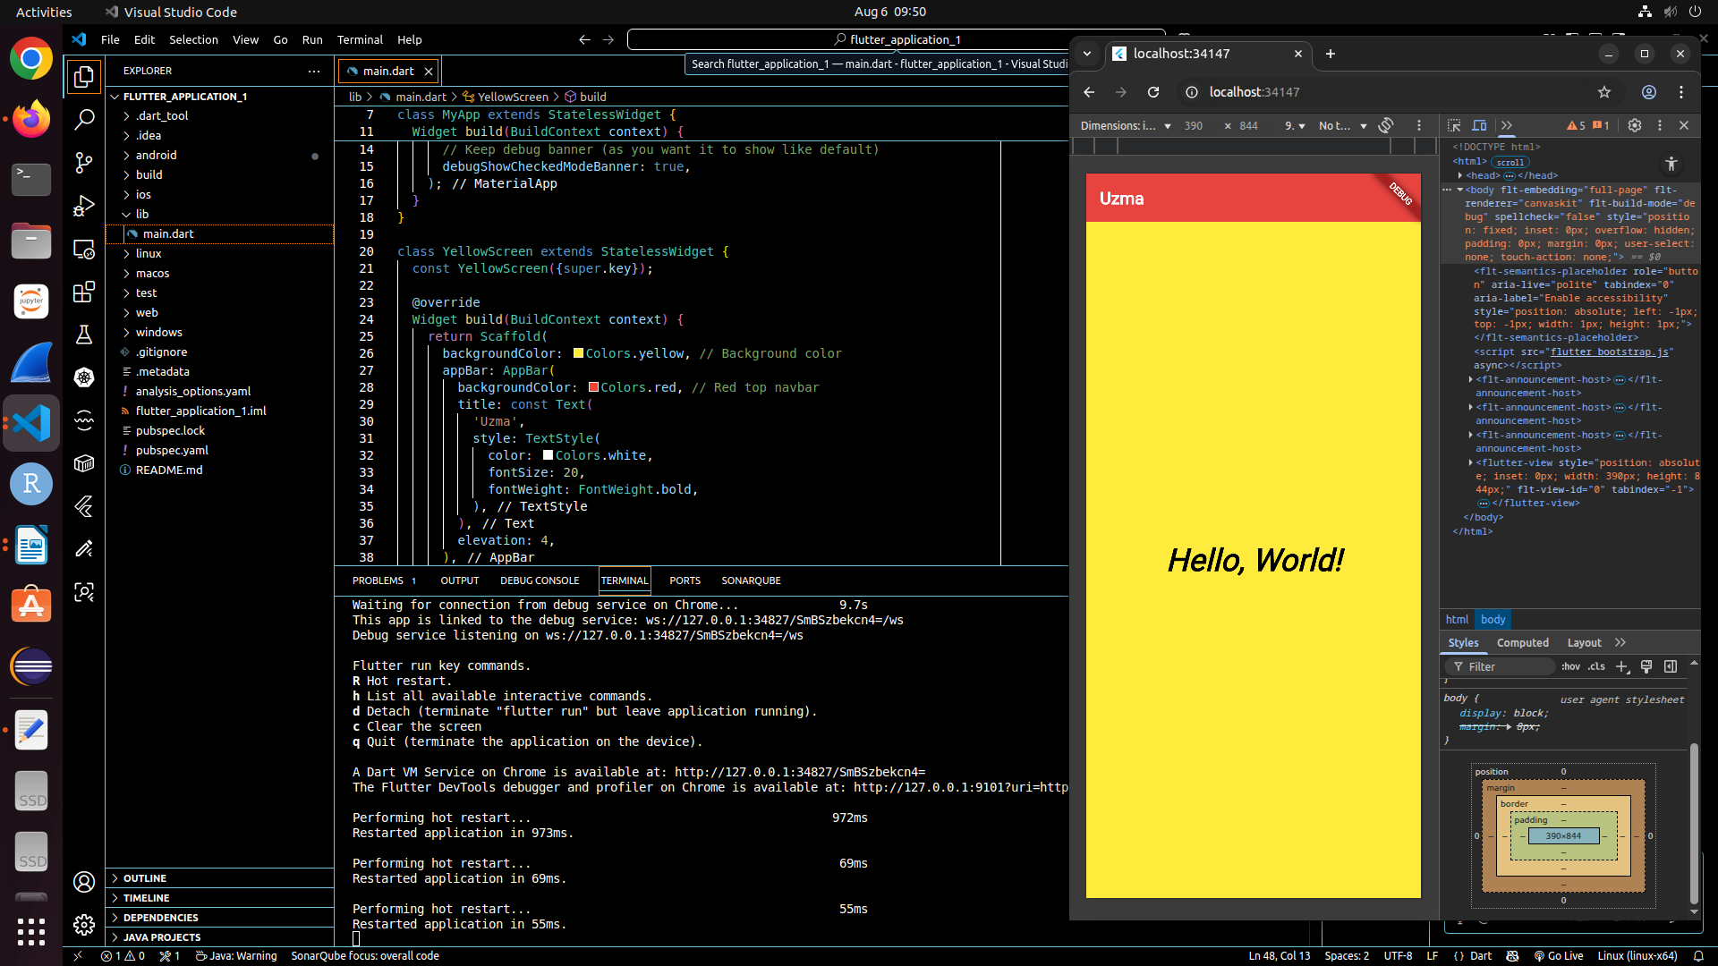
Exercise-2
import 'package:flutter/material.dart';

void main() {
runApp(const MyApp());
}

class MyApp extends StatelessWidget {
const MyApp({super.key});

@override
Widget build(BuildContext context) {
return const MaterialApp(
home: CustomScreen(),
debugShowCheckedModeBanner: true,
);
}
}

class CustomScreen extends StatelessWidget {
const CustomScreen({super.key});

@override
Widget build(BuildContext context) {
return Scaffold(
backgroundColor: Colors.white,
appBar: AppBar(
backgroundColor: Colors.blue,
title: const Text(
'RichText Example',
style: TextStyle(color: Colors.white, fontWeight: FontWeight.bold),
),
),
body: Center(
child: RichText(
text: const TextSpan(
style: TextStyle(fontSize: 18, color: Colors.black),
children: [
TextSpan(text: 'hello '),
TextSpan(
text: 'bold ',
style: TextStyle(
color: Colors.blue,
fontWeight: FontWeight.bold,
),
),
TextSpan(
text: 'world! ',
style: TextStyle(color: Colors.green),
),
TextSpan(text: 'this is a '),
TextSpan(
text: 'different color',
style: TextStyle(color: Colors.red),
),
],
),
),
),
);
}
}

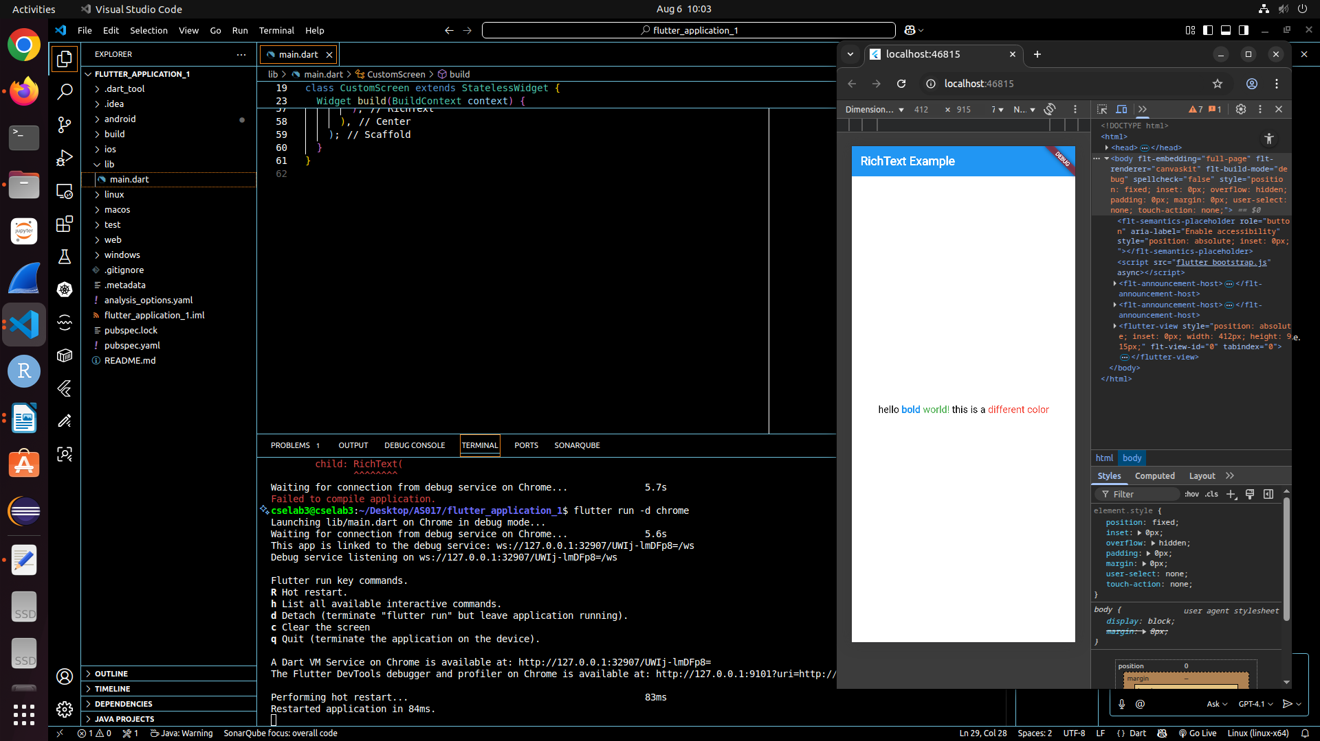
Exercise-3
3)
import 'package:flutter/material.dart';

void main() {
runApp(const MyApp());
}

class MyApp extends StatelessWidget {
const MyApp({super.key});

@override
Widget build(BuildContext context) {
return const MaterialApp(
home: CustomScreen(),
debugShowCheckedModeBanner: true,
);
}
}

class CustomScreen extends StatelessWidget {
const CustomScreen({super.key});

@override
Widget build(BuildContext context) {
return Scaffold(
backgroundColor: Colors.white,
appBar: AppBar(
backgroundColor: Colors.blue,
title: const Text(
'chiranthan',
style: TextStyle(color: Colors.white, fontWeight: FontWeight.bold),
),
),
body: Center(
child: Column(
mainAxisSize:
MainAxisSize.min, // Center vertically without extra space
children: const [
Text(
'name: Chiranthan',
style: TextStyle(
fontSize: 32, // Biggest font size
fontWeight: FontWeight.bold,
),
),
SizedBox(height: 8), // Small space between lines
Text(
'USN:1MS24AS017',
style: TextStyle(
fontSize: 20, // Smaller font size
fontWeight: FontWeight.normal,
),
),
SizedBox(height: 6),
Text(
'Department: AEROSPACE',
style: TextStyle(
fontSize: 14, // Smallest font size
fontWeight: FontWeight.normal,
),
),
],
),
),
);
}
}

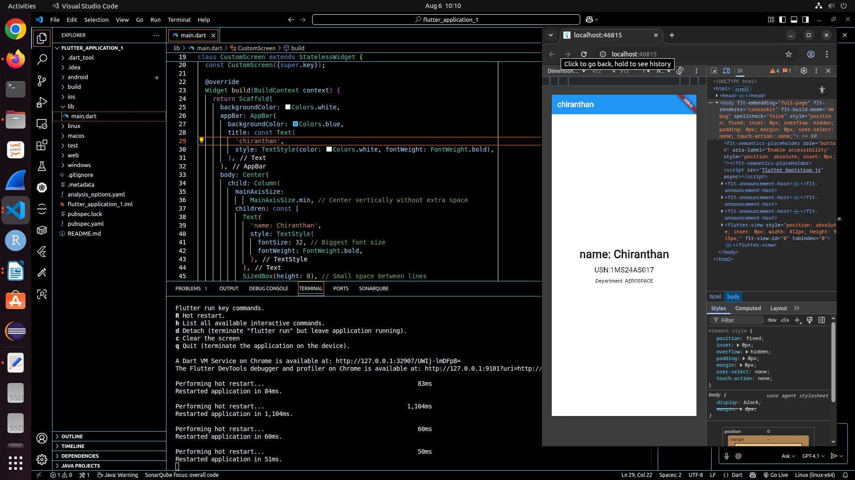
Exercise-4
4)
import 'package:flutter/material.dart';

void main() {
runApp(const MyApp());
}

class MyApp extends StatelessWidget {
const MyApp({super.key});

@override
Widget build(BuildContext context) {
return const MaterialApp(
home: CustomScreen(),
debugShowCheckedModeBanner: true,
);
}
}

class CustomScreen extends StatelessWidget {
const CustomScreen({super.key});

@override
Widget build(BuildContext context) {
return Scaffold(
backgroundColor: const Color(0xFF4052D6), // Hex #4052D6
appBar: AppBar(
backgroundColor: Colors.grey, // Grey nav bar
title: const Text(
'text position in flutter',
style: TextStyle(color: Colors.white, fontWeight: FontWeight.bold),
),
),
body: Stack(
children: [
// 1. Top left corner
const Positioned(
top: 10,
left: 10,
child: Text(
'Top left corner',
style: TextStyle(color: Colors.black, fontSize: 28),
),
),

// 2. Specific Position (100, 200)
const Positioned(
top: 200,
left: 100,
child: Text(
'Specific Position (100,200)',
style: TextStyle(color: Colors.black, fontSize: 25),
),
),

// 3. Centered Text
Center(
child: Text(
'Centered Text',
style: TextStyle(color: Colors.black, fontSize: 28),
),
),

// 4. Bottom right corner
Positioned(
bottom: 10,
right: 10,
child: Text(
'Bottom Right corner',
style: TextStyle(color: Colors.black, fontSize: 28),
),
),
],
),
);
}
}

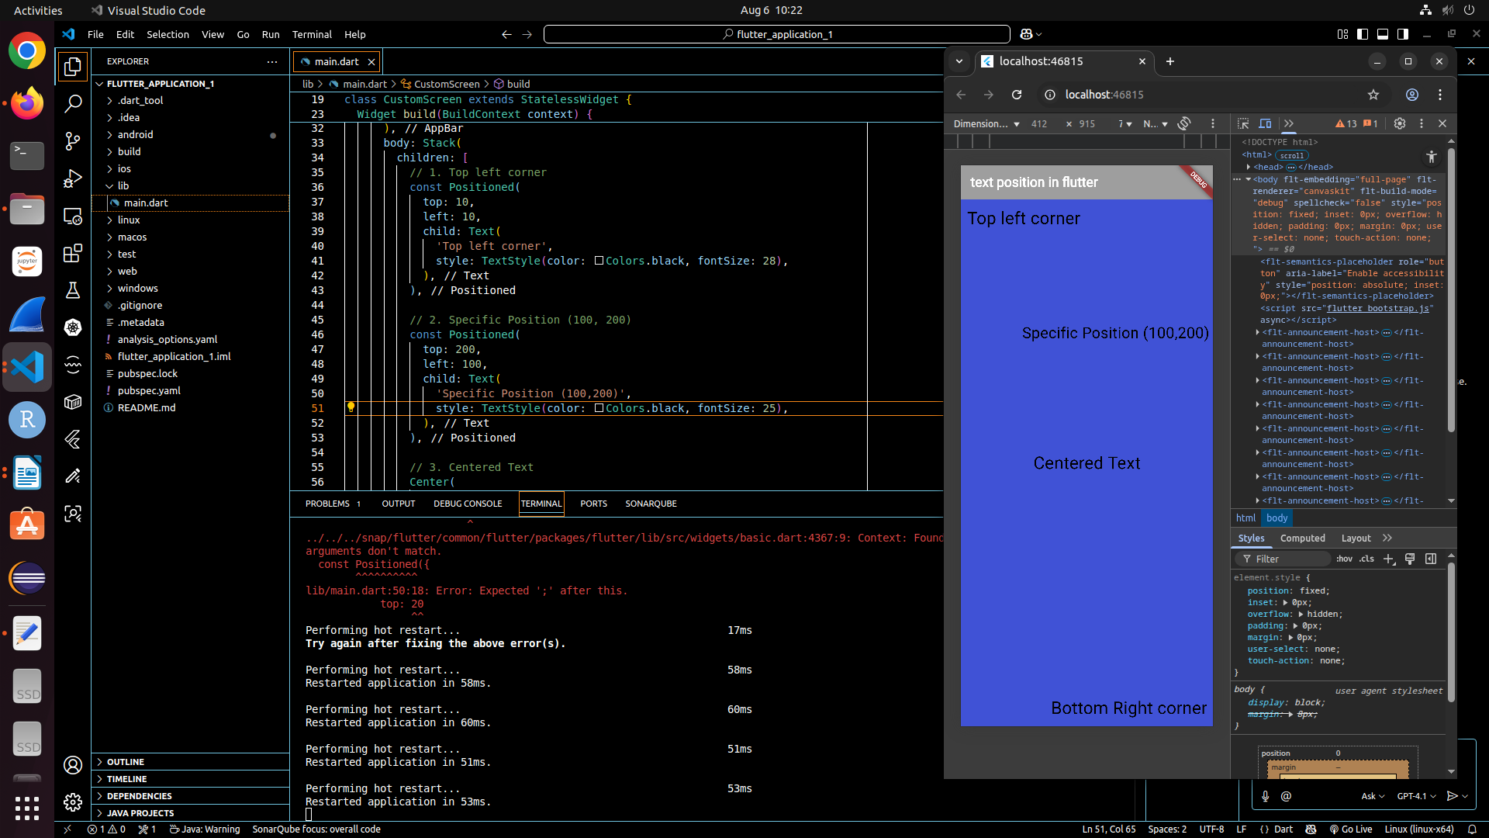
Exercise-5
5)
import 'package:flutter/material.dart';
import 'package:google_fonts/google_fonts.dart';

void main() {
runApp(Exercise5App());
}

class Exercise5App extends StatelessWidget {
@override
Widget build(BuildContext context) {
return MaterialApp(
title: 'Exercise 5',
home: Scaffold(
appBar: AppBar(
title: const Text('Different Font Types Example'),
backgroundColor: Colors.blue,
actions: [
Container(
padding: const EdgeInsets.all(8.0),
color: Colors.red,
child: const Text(
"DEMO",
style: TextStyle(
color: Colors.white,
fontWeight: FontWeight.bold,
),
),
),
],
),
body: Center(
child: Column(
mainAxisAlignment: MainAxisAlignment.center,
children: [
Text(
'Text with Times New Roman (via EB Garamond)',
style: GoogleFonts.ebGaramond(fontSize: 22),
),
SizedBox(height: 10),
Text(
'Text with Calibri (via Open Sans)',
style: GoogleFonts.openSans(fontSize: 22),
),
SizedBox(height: 10),
Text(
'TEXT WITH STENCIL (via Black Ops One)',
style: GoogleFonts.blackOpsOne(fontSize: 22),
),
SizedBox(height: 10),
Text(
'TEXT WITH ALGERIAN (via Special Elite)',
style: GoogleFonts.specialElite(fontSize: 22),
),
SizedBox(height: 10),
Text(
'Text with Edwardian Script (via Great Vibes)',
style: GoogleFonts.greatVibes(fontSize: 28),
),
],
),
),
),
);
}
}

Updated pubspec.yaml
name: flutter_application_1
description: "A new Flutter project."
publish_to: 'none'

version: 1.0.0+1

environment:
sdk: ^3.8.1

dependencies:
flutter:
sdk: flutter
cupertino_icons: ^1.0.8
google_fonts: ^6.1.0

dev_dependencies:
flutter_test:
sdk: flutter
flutter_lints: ^5.0.0

flutter:
uses-material-design: true

# Commented out custom fonts since we're using google_fonts now
# fonts:
# - family: TimesNewRoman
# fonts:
# - asset: fonts/times_new_roman.ttf
# - family: Calibri
# fonts:
# - asset: fonts/calibri.ttf
# - family: Stencil
# fonts:
# - asset: fonts/stencil.ttf
# - family: Algerian
# fonts:
# - asset: fonts/algerian.ttf
# - family: EdwardianScriptITC
# fonts:
# - asset: fonts/edwardian_script_itc.ttf

